Database Technologies

Q1
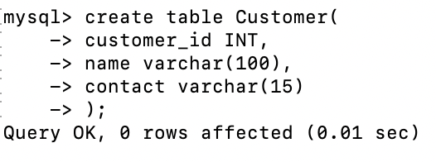
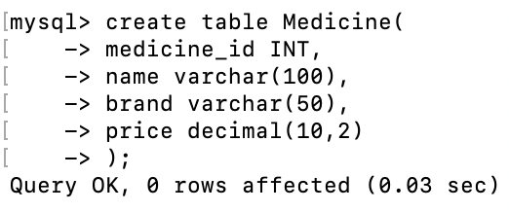
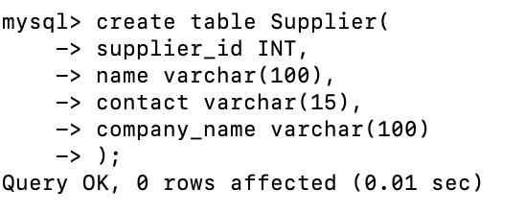
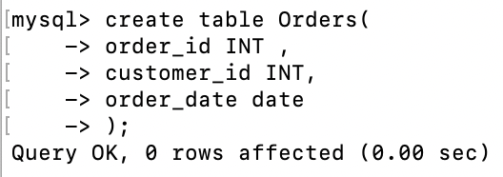
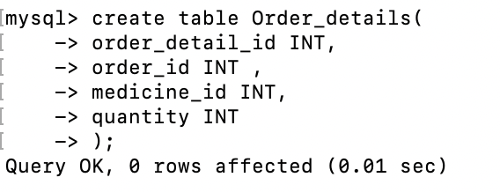

Q2

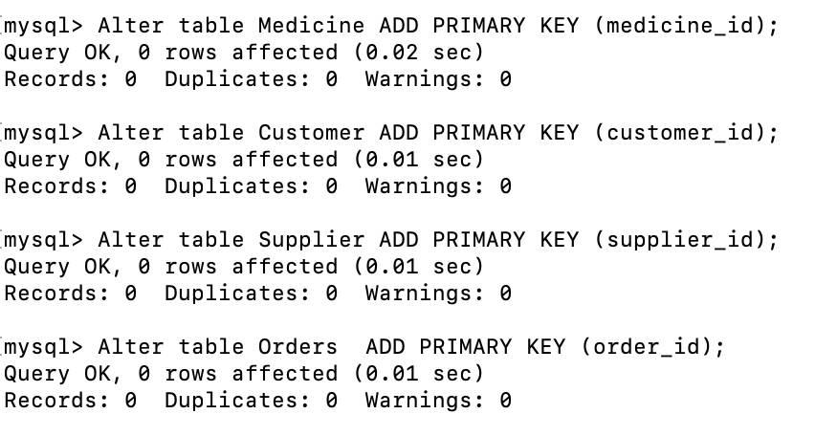

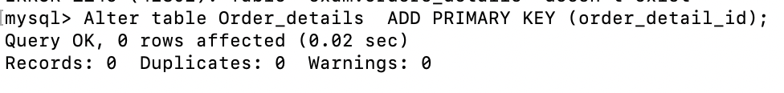

Q3

mysql> Alter table Orders ADD constraint fk_customer FOREIGN KEY (customer_id) References Customer(customer_id);
Query OK, 0 rows affected (0.02 sec)
Records: 0 Duplicates: 0 Warnings: 0

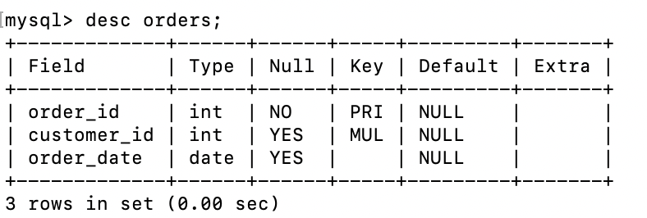

mysql> Alter table Order_details ADD constraint fk_order FOREIGN KEY (order_id) References Orders(order_id);
Query OK, 0 rows affected (0.02 sec)
Records: 0 Duplicates: 0 Warnings: 0

mysql> Alter table Order_details ADD constraint fk_medicine FOREIGN KEY (medicine_id) References Medicine(medicine_id);
Query OK, 0 rows affected (0.02 sec)
Records: 0 Duplicates: 0 Warnings: 0
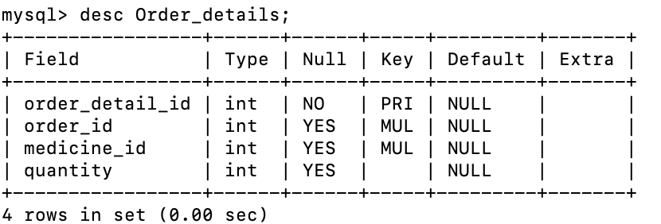

Q4
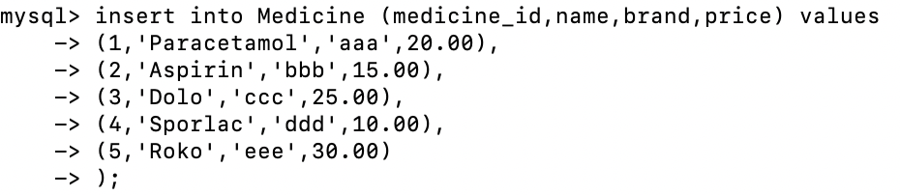
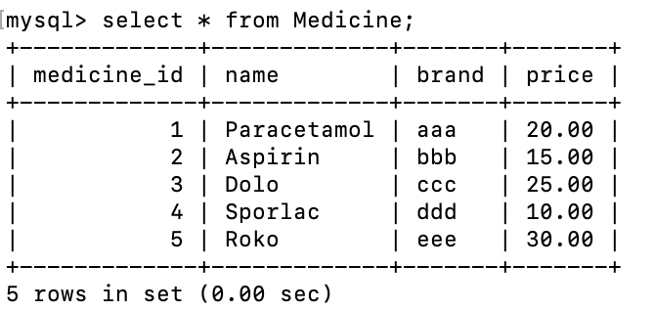

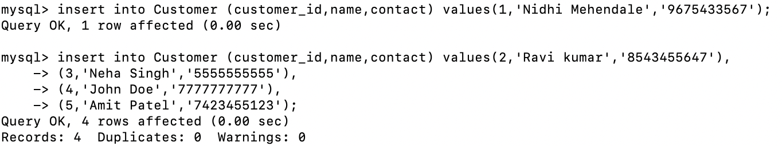
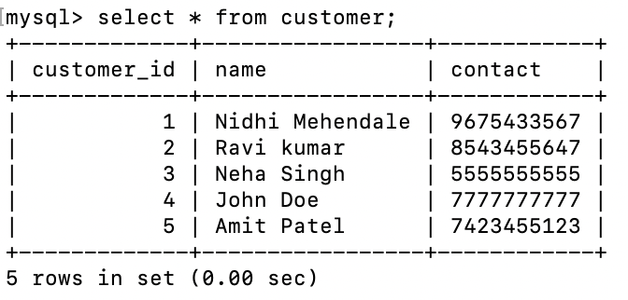

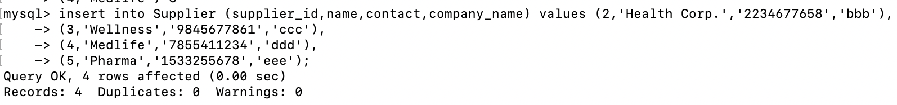
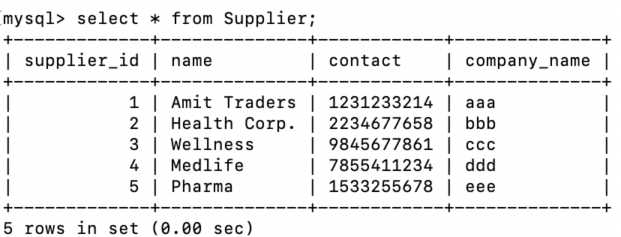

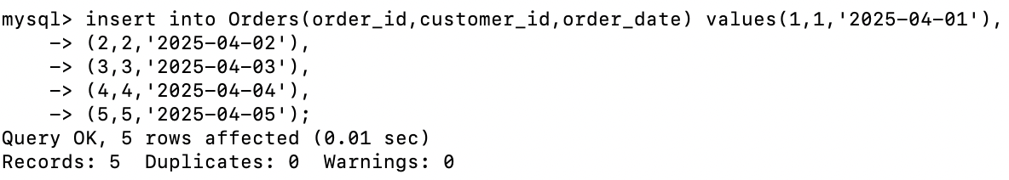
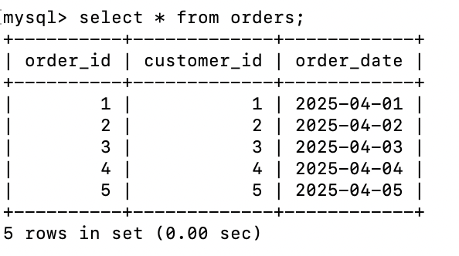

mysql> insert into Order_details(order_detail_id,order_id,medicine_id,quantity) values
-> (1,1,1,2),
-> (2,2,2,1),
-> (3,3,3,4),
-> (4,4,4,3),
-> (5,5,5,1);

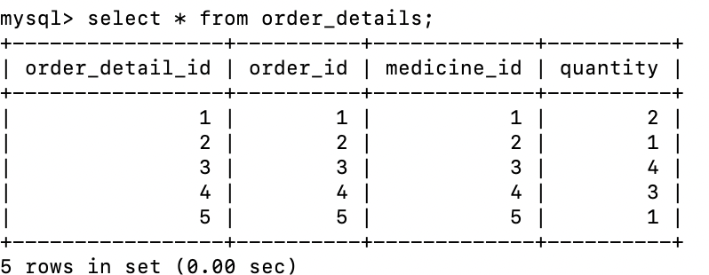

Q5

mysql> select * from Medicine
-> where name='Dolo' or price > 15;

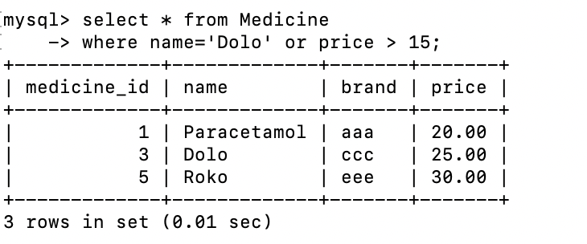

Q6

mysql> select * from Customer LIMIT 5;

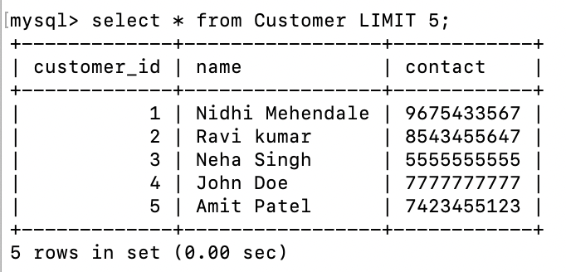

Q7

mysql> select name ,count(*) as total_medicines
-> from Medicine Group by name;

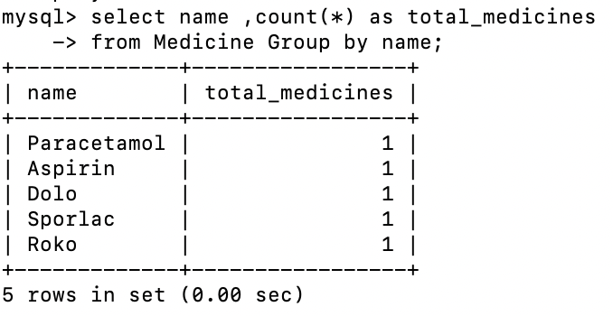

Q8
mysql> select name,price from Medicine
-> order by price desc
-> LIMIT 1 OFFSET 1;

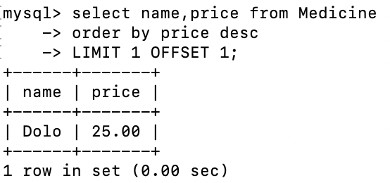

Q9
mysql> CREATE VIEW View_Medicine as
-> select * from Medicine;
Query OK, 0 rows affected (0.00 sec)

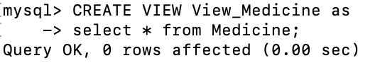

mysql> UPDATE View_Medicine
-> set price = 22.00
-> where medicine_id = 1;
Query OK, 1 row affected (0.00 sec)
Rows matched: 1 Changed: 1 Warnings: 0
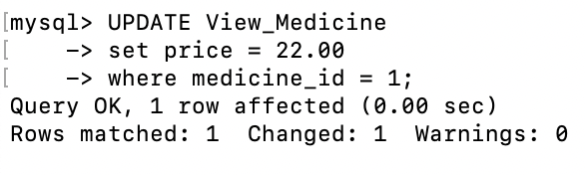

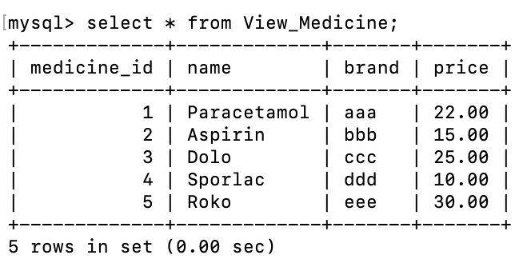

Q10

mysql> select Orders.order_id , Customer.name
-> from Orders
-> LEFT JOIN Customer on
-> Orders.customer_id = Customer.customer_id;

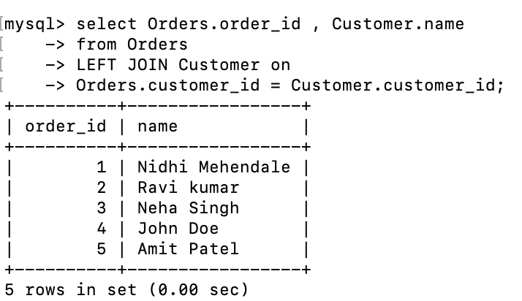

Q11

mysql> CREATE TEMPORARY TABLE aaa_Medicines as
-> select * from Medicine where brand='aaa';
Query OK, 1 row affected (0.00 sec)
Records: 1 Duplicates: 0 Warnings: 0

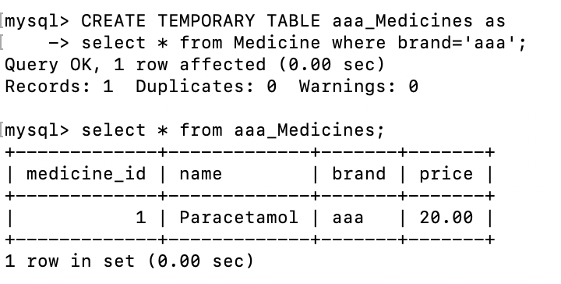
mysql> Drop TEMPORARY TABLE aaa_Medicines;
Query OK, 0 rows affected (0.00 sec)
